Deep RGB | June 7  2012
Bringing color and magic to your world…

Shenmin Lo, EE
Joseph Lunder, CpE
Siarhei Traskouski, EE
Robert Wadsworth II, EE

Description

From its earliest roots in the 6th Century CE through the formulation of its modern form in early-Renaissance Italy, and all the way to the modern day, chess has been a popular and deep game that tests its players' knowledge of strategy and (until recently, some would claim) creativity. Though it is a game played normally by two people sitting at a common table with the board between them, for centuries remote games have been played by letter, telegraph, and more recently email. More impressively, since the tail end of the 20th Century, computers have been programmed to compete with, and eventually overtake, human players in Man Versus Computer games.
Our proposed design integrates the comfortable heft of playing a physical game of chess with a live opponent with the convenience of having that opponent be potentially hundreds of miles away, if not simply a computer program. A chess board with a magnetic piece-moving system sends and receives information relating to moves in a game to a server that will either allow the other participant of the game to make a move or calculate a move from one of a handful of difficulty levels of chess algorithm. The server will allow for multiple methods of updating a game, not simply the physical board, but also a web interface.
The chess board itself will utilize hall effect sensors to detect movement and placement of chess pieces with embedded magnets. These pieces will be moved physically by the board itself through the use of a larger magnet underneath the board that is positioned on an X,Y coordinate system by a set of stepper motors on sliding paths to allow for precise movement. It will also include an array of LEDs that will light up the pieces when they are stationary and switch to flash on valid moves when a piece is removed for placement by the human player. The board is also capable of storing music and sound effects on an internal SD card and playing those back at specific times during the game.
The server software will be a centralized set up that will house the distinct chess algorithms relating to difficulty along with the multiplayer and saved game functionalities. The server can be located remotely, to allow for long distance play by people outside the board's immediate local area network or nearby, disallowing truly remote play, but allowing for computer play without requiring an internet connection. The software will be somewhat agnostic to the method of play for each player in any given game. A player could be a human playing on the physical chess board, a remote player using a potential copy of the board or a web interface of some sort, or a computer player. Either player can be represented in this manner, allowing for potentially a computer versus computer game being shown on the board requiring absolutely no input from the local user and providing an interesting distraction or conversation piece.

Specifications:
Chess board:
- An 8 by 8 matrix with sufficient space for pieces to move between each other
- Less than 1 Cm thick to prevent too much magnetic attraction loss
- Frosted glass to hide the sensors and give the board a clean look
- Weigh less than 5 Kg to keep it light and portable
- No larger than 40 by 40 Cm
Power supply:
- Capable of plugging into a household 120V 60 Hz AC outlet
- Supplying 3.6, 5 and 12V DC to the internal components
Microcontroller
- A clock speed of 16MHz or higher microcontroller unit with sufficient I/O pin outs to control all movement and sensory tasks
- Both digital and pulse width modulating I/O pin outs available
- Minimum of 16 analog inputs
- Minimum 256k Flash memory
Wireless data transmitter:
- Capable of connecting to the 802.11b/g standard
- Minimum transfer rate of 1 Mbps
- Secure WiFi authentication capabilities
- Minimum 80 m transmission range
- Low power consumption of less than 150 mW
- Sleep mode option
Hall-effect sensors:
- 8 by 8 matrix
- Linear analog output
- Capable of measuring up to 5 Tesla
Magnetic piece positioning system:
- Two 200 steps/rev stepper motors capable of over 60 RPM
- Torque rating of more than 75N*Cm
- One standard servo to raise and lower the movement magnet
- Rails for both the x and y plane of the board
- Neodymium magnets within each piece to make them movable

RGB LED matrix:
- 8 by 8 matrix controlled by 6 digital pins
- 5V running voltage
- 7 selectable colors
- Interactive lighting to simulate combat between pieces
Audio:
- Embedded SD card capable of storing music and sound effects
- Sampling rates of 6KHz to 36KHz
- Stereo 8 ohm speaker output
- Sleep mode option
LCD display:
- 16 by 2 LCD character display
- 5 by 2 dots with cursor
Server:
- Internet connection required
- Minimum requirements of 1GHz processor with 2 GB of RAM
- Receives updated piece placement from board and allows for game saves
- Capable of interacting with multiplayer application or computer chess algorithm to send next move back to board

Project block diagram

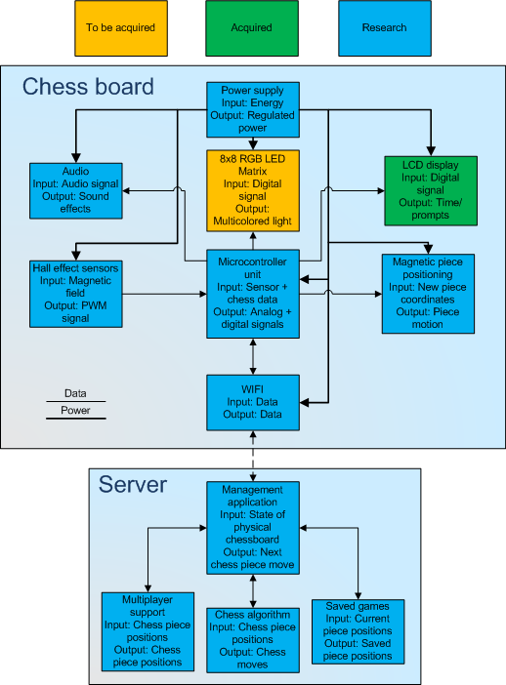
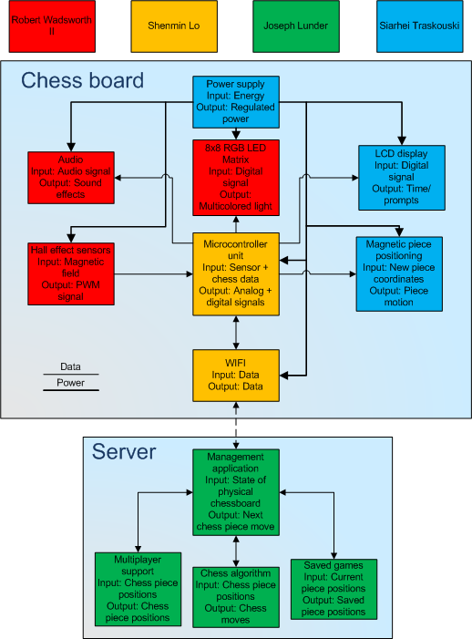

Budget and financing

Item | Price
Hall effect sensors | $100
LEDs | $80
Motors | $100
Processor and PCB | $300
Wiring | $15
Power management | $50
Wireless data transmission | $50
Glass surfaces | $50
Unpredictable expenses | $100
Total | $845
Financing burden is to be spread evenly among all members.

Milestones
Timeframe | Milestones
Week of 6/4 | New project idea decided on and expanded upon.  Initial research on magnet types, sensor types, and server software set up.  New Project Design Proposal document drafted and submitted
Week of 6/11 | Specific research on magnets and electromagnets. The magnet must be able to work over a small space including the glass surface, and electronics.  Specific research on motor and track mounts  Final decision on magnet  The magnet will already be in our possession for testing purposes
Week of 6/18 | Begin microcontroller experimentation  Familiarize group with the functions available on the microcontroller  Test motors and track mounts to ensure that they operate within parameters required
End of June | Design Hall effect sensor configuration  Prototype configuration and test with microcontroller  Test wifi data transmission  Determine best way to transmit data through wifi for the best cost
Mid July | Design LED configuration  Prototype configuration and test with microcontroller  Ensure that the LEDs, Hall effect sensors and motors do not accumulate to more inputs and outputs than the microcontroller can handle  Assign paper sections
End of July | Design full integration  Begin microcontroller integration testing  Complete individual paper sections
August 2nd | Paper completed and turned in
Mid August | Compile remaining parts yet un-purchased
End of August | Initial build of Chess boards complete
September - October | Continuing testing and refinement of the algorithm that maneuvers the pieces as well as the data transfer over wifi  Divide and begin work on final paper
Mid November | Finalization of game(You should be able to play the board or someone else and play with web interface)  Begin presentation prep  Share work done on paper, make any final adjustments to division of labor
End of November | Due to Thanksgiving:  Reduced testing of Chess board  Refinement of program to account for any errors or undesirable attributes
Start of December | Project Complete  Demonstrate

